Lab 7 , 8 Task for Analysis of Algorithm
Name:Umar Ahad Uddin Ahmed Usmani
SAP :60199
Task 1 :

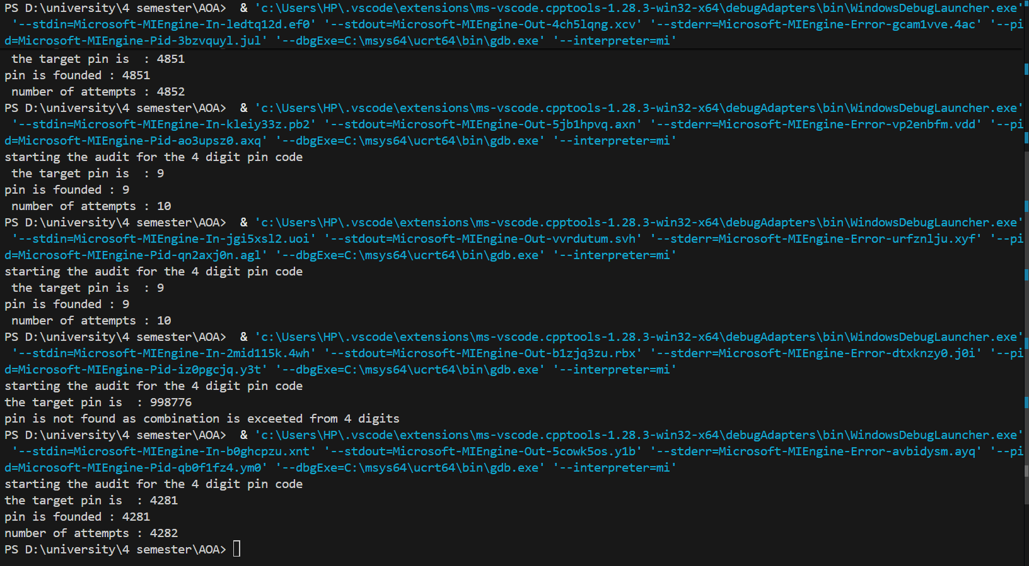

#include<iostream>
#include<string>
#include<iomanip>

using namespace std ;

void bruteForcePin(string targetPin){
cout<<"starting the audit for the 4 digit pin code"<<endl;
cout <<"the target pin is : "<< targetPin<<endl;
int target = stoi (targetPin);
int attempts =0;
bool found = false;
for (int i=0; i<=9999;i++)
{
attempts++;
if (i == target)
{
found = true;
cout<<"pin is founded : "<< i << endl;
cout <<"number of attempts : "<< attempts <<endl;
break;

} }

if (!found)
{cout<<"pin is not found as combination is exceeted from 4 digits"<<endl;

}
}
int main (){

string targetPin = "4281";
bruteForcePin (targetPin);
return 0;

}

In this task the by using the brute force we know that they check for each combination as for 4 digit they have to check 10000combination which is normal but for 6 to 8 digit they have to check the
For 6 digit about 1,000,000 which is about 100x more then 4 digit combination and for 8 digit they have to check about 100,000,000 which is about 1000x more than 4 digit combination that made the system too slow that why we not use this .

Task 2 :
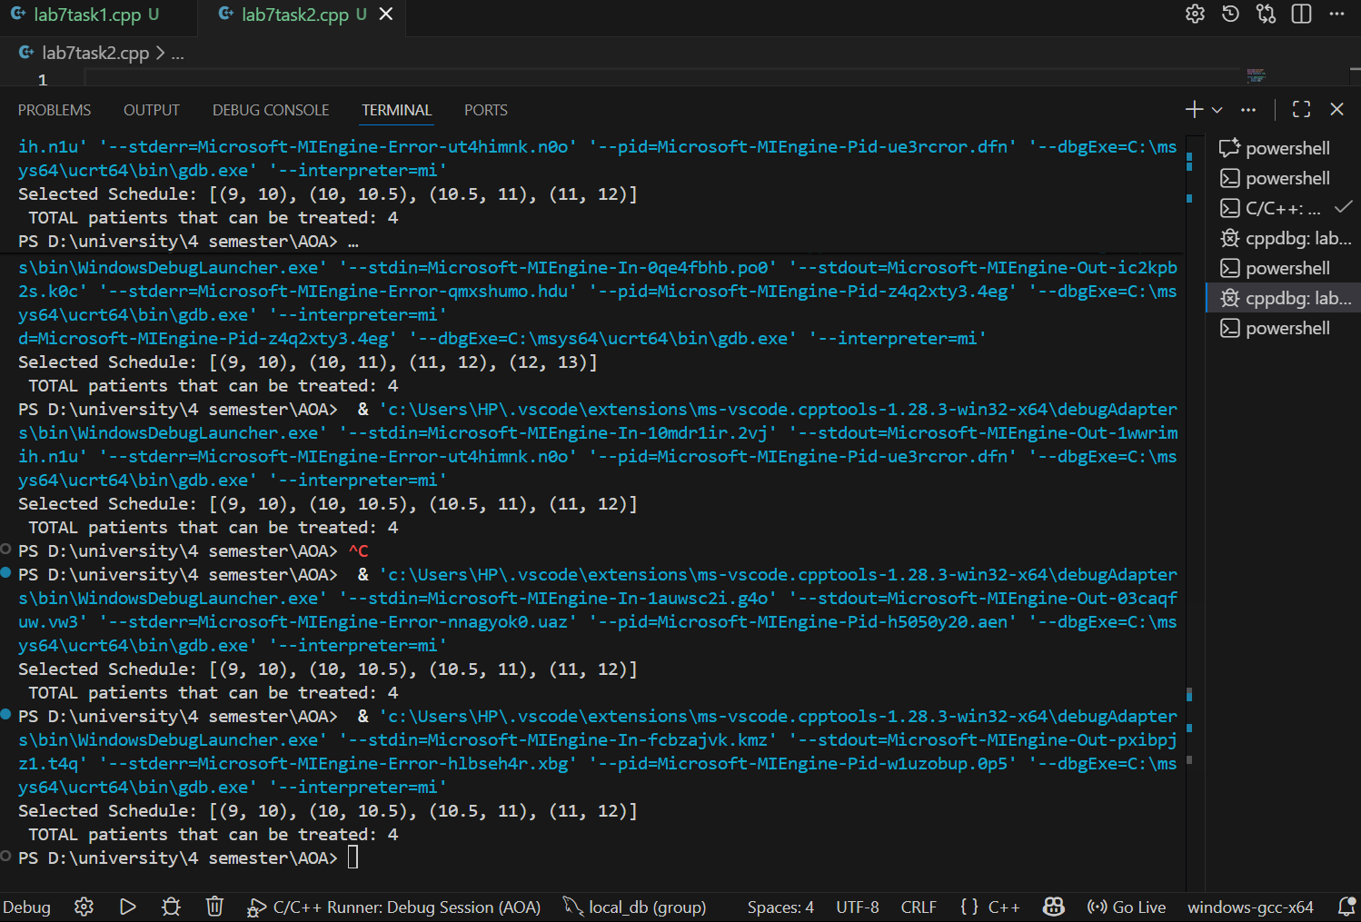
\

#include<iostream>
#include<vector>
using namespace std;

struct Appointment {
double start;
double end;
};

void optimizeSchedule(vector<Appointment>& appointments){
int n = appointments.size();

for (int i = 0 ; i < n-1 ; i++){
for (int j = 0 ; j < n-i-1; j++){
if (appointments[j].end > appointments[j+1].end){
Appointment temp = appointments[j];
appointments[j] = appointments[j+1];
appointments[j+1] = temp;
}
}
}

vector<Appointment> selected;

if (!appointments.empty()){
selected.push_back(appointments[0]);
}

if (!selected.empty()) {
double last_end_time = selected[0].end;

for (int i = 1 ; i < appointments.size(); i++){
if (appointments[i].start >= last_end_time){
selected.push_back(appointments[i]);
last_end_time = appointments[i].end;
}
}
}

cout << "Selected Schedule: [";
for (size_t i = 0; i < selected.size(); i++) {
cout << "(" << selected[i].start << ", " << selected[i].end << ")";
if (i < selected.size() - 1) cout << ", ";
}
cout << "]" << endl;
cout <<" TOTAL patients that can be treated: " << selected.size() << endl;
}

int main()
{
vector<Appointment> appointments = {
{10.5, 11.0},
{9.0, 10.0},
{9.5, 11.0},
{10.0, 10.5},
{11.0, 12.0},

};
optimizeSchedule(appointments);
return 0;
}

